## Introduction

This Switch Adapted Remote Controlled Car is compatible with 3.5 mm assistive switches. This device may be beneficial for someone with limited hand function that is interested in a remote controlled car, or for teaching cause and effect with assistive switches.

## Features

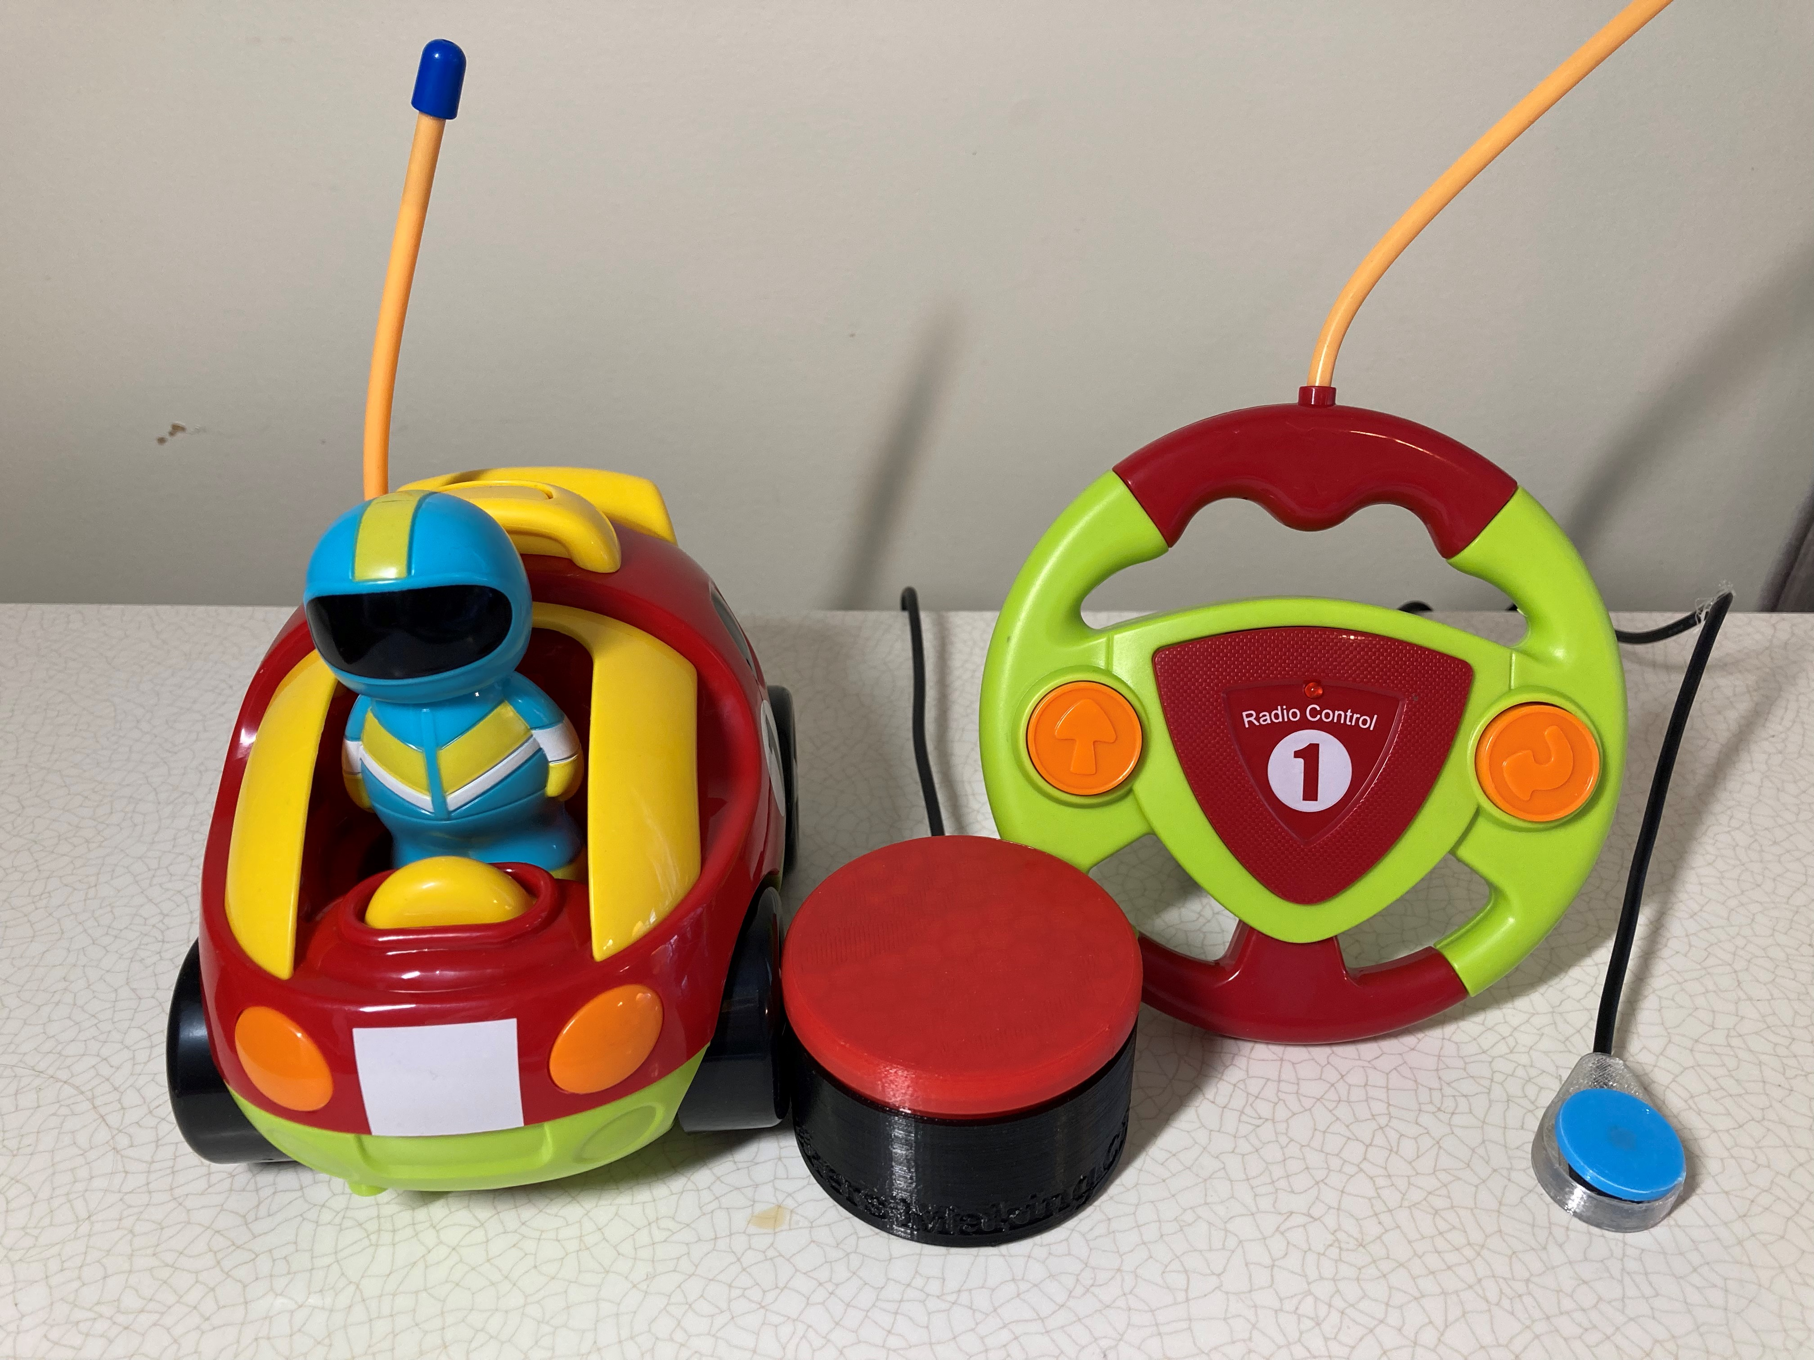

LED

Button: Forward

Button: Reverse and turn

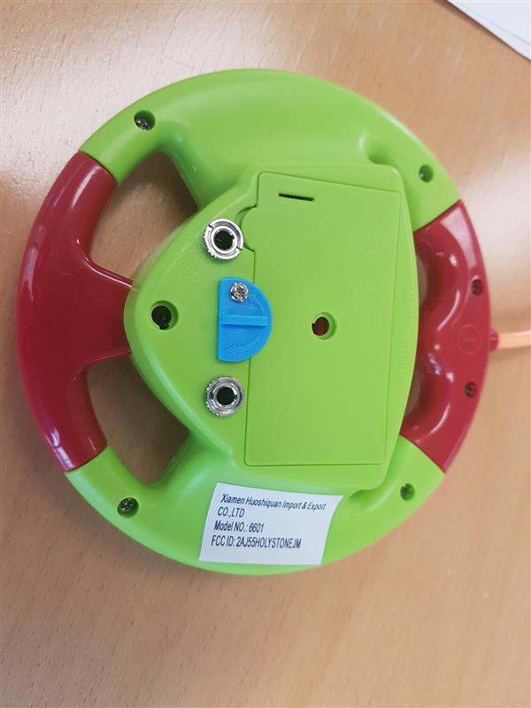

3.5 mm assistive switch jacks

Battery compartment

## Usage

Make sure both the car and the remote have batteries. The remote needs 2 AA batteries and the car needs 3 AA batteries.

Turn on the car, with the switch on the bottom of the car.

Plug in assistive switches to the two 3.5 mm jacks on the back of the remote. The switch plugged into the jack on the same side as the forward button (left if you are looking from the front) will make the car move forwards, and the switch plugged into the jack on the same side as the reverse button (right if you are looking from the front) will move the car backwards and cause it to turn.

There are additional noises that the car can make that are not switch adapted, these are activated by pushing down the driver of the car, pushing down the steering wheel on the car, or pushing the button on the top of the car on the yellow piece.

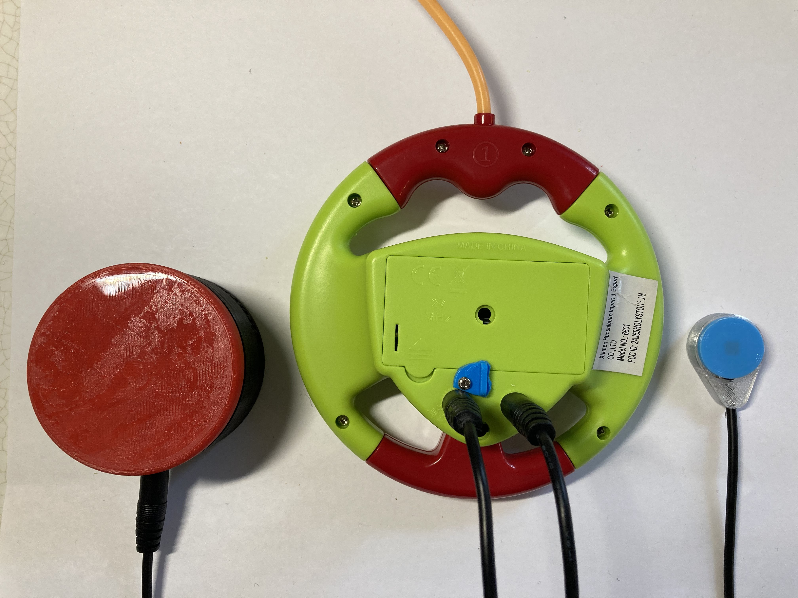

Forwards switch

Reverse and turn switch

## Compatibility

This adapted toy is compatible with assistive switches that have a 3.5 mm plug.

## Cleaning

The toy can be wiped down with a cloth. Do not submerge.